Soluzioni

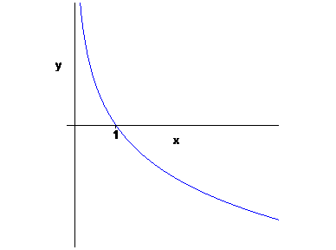
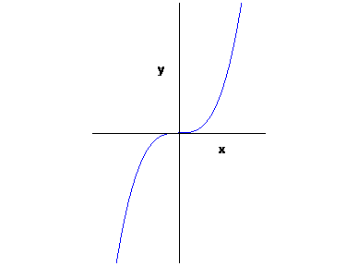
1.

( a ) ( b )

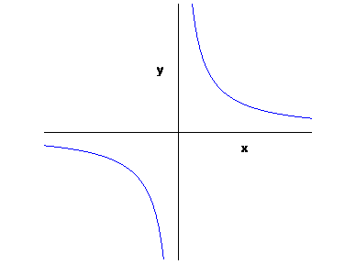
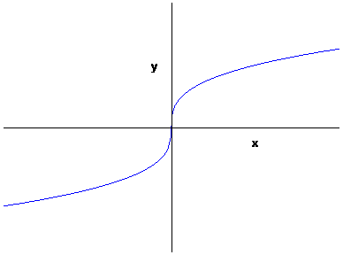
( c ) ( d )

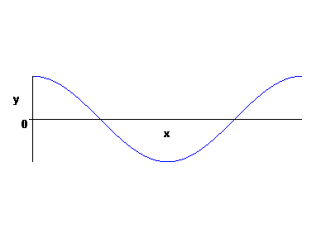
( e )

Grafico per 0 ≤ x ≤ 2π ; funzione di periodo 2 π

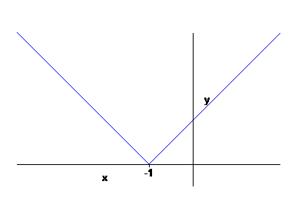
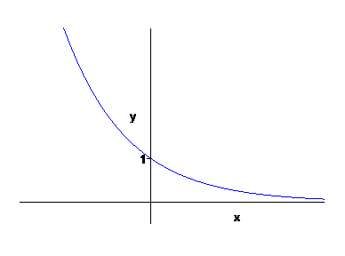
( f ) ( g )

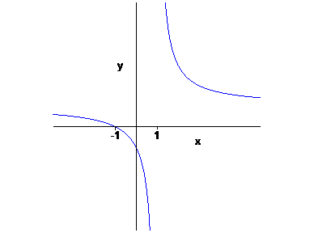
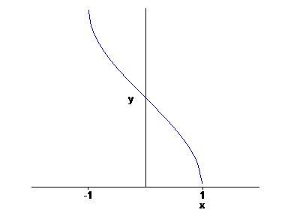
( h ) ( i )

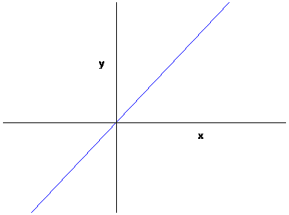
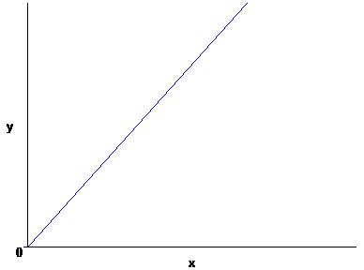
( l ) ( m )

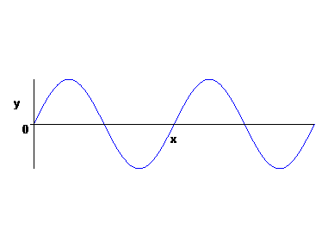
( n )
Grafico tracciato per 0 ≤ x ≤ 2π
Funzione di periodo π
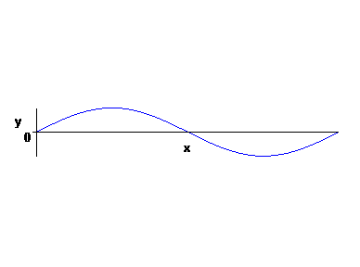
( o )
Grafico tracciato per 0 ≤ x ≤ 4π
Funzione di periodo 4π

( p )
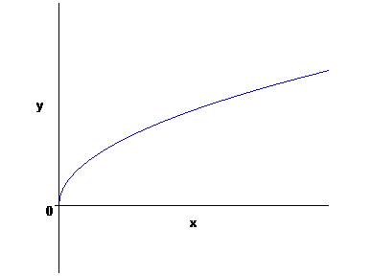

2.
( a ) a^{b} a^{c} ( b ) | x | ( c ) x
( d ) log | a | + log | b | ( e ) 2 log | a | + log b ( f ) sena cosb + cosa senb
( g ) cos²x – sen²x ( h ) $±\sqrt{(\text{ 1 - cosx })\text{/ 2}}$ ( i ) ½
( l ) π/6 ( m ) ¼ ( n ) ½
( o ) 2 ( p ) $−(\sqrt{\text{ 3}}\text{ /2 })+1−(\text{ 1/}\sqrt{2})$

3.
( a ) sempre verificata ( b ) -1 ≤ x ≤ 1 ( c ) $\text{x }≤\text{ 1 - }\sqrt{\text{ 5}}\text{ ; 1 }<\text{ x }≤\text{ 1 }+\sqrt{\text{ 5}}$
( d ) $(\text{ - 5 - 2 }\sqrt{\text{ 10}})\text{ / 3 }≤\text{ x }≤ (\text{ - 5 }+\text{ 2 }\sqrt{\text{ 10}})\text{ / 3}$ ( e )$\text{ x }≤{\text{ log }}_{\text{9/5}}\text{ 30}$ = log 30 / log ( 9 / 5 )
( f )$\text{ x }≤ (\text{ - 3 }+\sqrt{\text{ 33}})\text{ / 6}$ ( g ) x = 2 ; x = 1 / $\sqrt{\text{ 2}}$ ( h ) 2 k π ≤ x ≤ π/2 + 2 k π
( i ) π/2 + 2 k π ≤ x ≤ 2π – arcsen ( 3 / 5 ) + 2 k π
( l ) 2 k π ≤ x ≤ π + 2 k π oppure 7π/6 +2 k π ≤ x ≤ 11π/6 + 2 k π
( m ) $\text{1 - }\sqrt{\text{ 2}}≤\text{ x }≤\text{ 1 }+\sqrt{2}$ ( n ) - 1 ≤ x ≤ 3 ( o ) 2π/3 + 2 k π < x < 4π/3 + 2 k π
( p ) 2 k π < x < π/3 + 2 k π oppure 2π/3 +2 k π ≤ x ≤ π + 2 k π
( q ) -π/6 + k π < x < π/6 + k π

4.
( a ) 1 ≤ x ≤ 2 ( b ) π/3 + k π < x < 2π/3 + k π ( c ) x < -1 oppure x > 3
( d ) x ≤ 0 oppure x ≥ 1 ( e ) π/6 + k π ≤ x < 5π/6 + k π ( f ) - 5 ≤ x < 2
( g ) x > ${\text{log}}_{2}\frac{\sqrt{\text{ 13}}\text{ - 1}}{2}$ ( h ) x > 0 ( i ) -1/3 < x < 1/3
( l ) 1 ≤ x ≤ 5 ( m ) -3 ≤ x ≤ 5 ( n ) x ≥ 0
( 0 ) nessuna soluzione ( p ) $\text{π / 6 }+\text{ 2kπ }<\text{ x }<\text{ 5 π / 6 }+\text{ 2kπ}$

5.
( a ) x > -3 , x ≠ -2 ( b ) x > 3 , x ≠ 4 ( c ) x ≠ exp ( π/2 + k π )
( d ) x < -2 oppure x > 3 ( e ) x > 1 ( f ) x > 0 , x ≠ 1
( g ) 0 < x < 3 , x ≠ 1 ( h ) x > -5 , x ≠ 1 , x ≠ -3 ( i ) x ≤ 0 oppure x ≥ 2
( l ) 2 k π < x < π + 2 k π ( m ) $\text{-1 }≤\text{ x }<(\text{ 1 }+\sqrt{\text{ 5}})\text{ / 2}$ ( n ) x ≥ 0
( o ) -1 < x ≤ 3 ( p ) x > -1/2 , x ≠ 0 ( q ) x ≠ π/2 + 2 k π

6.
( a ) 2π/3 ( b ) π ( c ) π
( d ) non periodica ( e ) π/4 ( f ) non periodica

7.
( a ) cresce ( b ) decresce ( c ) decresce
( d ) decresce ( f ) non è monotòna ( g ) non è monotòna

8 .
( a ) C.E. x ≥ 0 , x ≠ 4 Imm k < -2 opp. k ≥ 3/2 $f^{\text{-1}}(\text{ k }) = {\left(\frac{\text{2 k - 3}}{\text{y }+\text{ 2}}\right)}^{2}$
( b ) C.E. x ≠ 1 Imm k > 0 , k ≠ e $f^{\text{-1}}(\text{ k }) = \frac{\text{log k }+\text{ 1}}{\text{log k - 1}}$
( c ) C.E. R Imm π/2 < k < π/2 $f^{\text{-1}}(\text{ k }) =\text{ 3 tg }(\text{ k / 2 })\text{ - 1}$
( d ) C.E. R Imm k > -6 $f^{\text{-1}}(\text{ k }) =\text{ log }\left(\frac{\sqrt{\text{25 }+\text{ 4 k}}\text{ - 1 }}{2}\right)$
( e ) C.E. x > 0 Imm π/2 < k < π/2 $f^{\text{-1}}(\text{ k }) =\text{ exp }(\text{ tg k - 1 })$
( f ) C.E. R Imm ½ < k < 2 $f^{\text{-1}}(\text{ k }) =\text{ log }\frac{\text{k }−\text{ 2}}{\text{1 - 2k}}$
( g ) C.E. x ≥ 0 Imm 0 ≤ k < π/2 $f^{\text{-1}}(\text{ k }) ={\text{ - log}}_{2}\text{ cosk}$
( h ) C.E. -1 ≤ x ≤ 1 Imm $\text{5 - 3}\sqrt[\text{ 3 }]{\text{ π / 2 }} ≤\text{ k }≤\text{ 5 }+\text{ 3}\sqrt[\text{ 3 }]{\text{ π / 2 }}$ $f^{\text{-1}}(\text{ k }) =\text{ sen }{\left(\frac{\text{k - 5}}{3}\right)}^{2}$
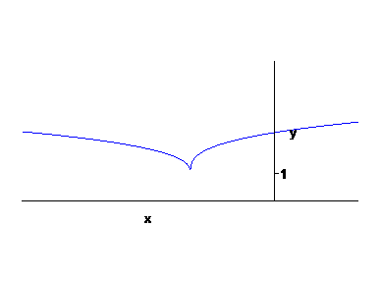
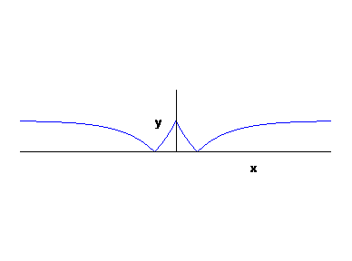
9.
( a ) ( b )

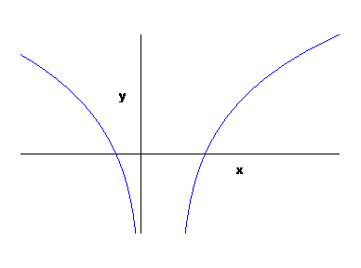
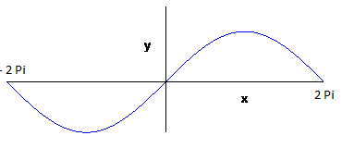
( c ) ( d )

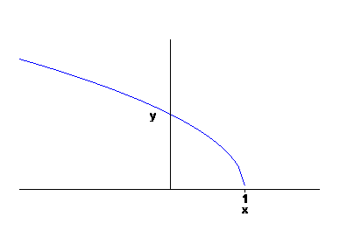
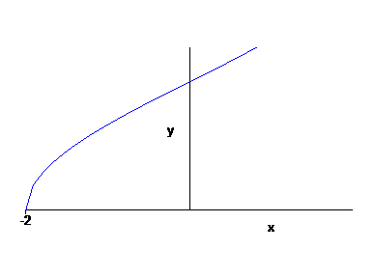
( e ) ( f )

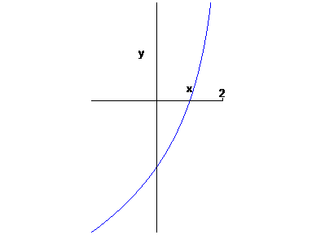
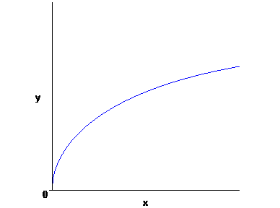
( g ) ( h )

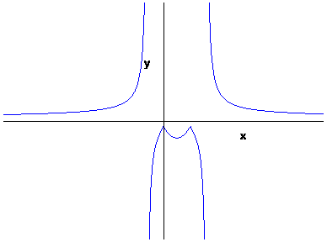
( i ) ( l )
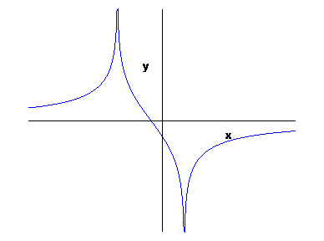

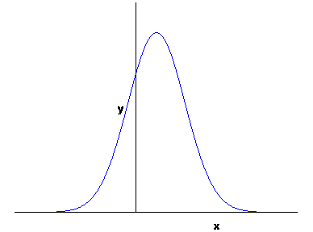
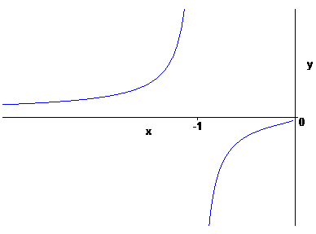
( m ) ( n )

10.
( a ) 2 $\sqrt{\text{ 2}}$ / 3 ( b ) 2 $\sqrt{\text{ 2}}$ / 3 ( c ) 1 / $\sqrt{\text{ 15}}$

11.
( a ) arccos 3/5 arcsen 4/5 arctg 4/3
( b ) arccos ( - 3/5 ) π – arcsen 4/5 π – arctg 4/3
( c ) 2 π – arccos ( -3/5 ) π + arcsen 4/5 π + arctg 4/3
( d ) 2 π – arccos 3/5 2 π – arcsen 4/5 2 π – arctg 4/3

12.
( a ) funzione iniettiva; $∃{\text{ x}}_{1}{\text{ , x}}_{2}∈{\text{ A : x}}_{1}≠{\text{ x}}_{2} ∧\text{ f }({\text{ x}}_{1})=\text{ f }({\text{ x}}_{2})$
( b ) funzione limitata superiormente; $∀\text{ M }∈\text{ R }∃ \overline{x}∈\text{ A : f }(\overline{x})>\text{ M}$
( c ) funzione surgettiva; $∃\text{ k }∈\text{ R : }∀\text{ x }∈\text{ A f }(\text{ x })≠\text{ k}$
( d ) definizione di funzione ; $∃\overline{x}∈\text{ A : }$f ($\overline{x}$ ) non esiste oppure non è univocamente determinato

13.
( a ) Q ( x ) = x² + 3 x + 3 R ( x ) = 4 ( b ) Q ( x ) = 2x² - 2 x + 3 R ( x ) = -2x

14.
( a ) $\text{f }(\text{ g }(\text{ x })) =\text{ exp }(\sqrt{\text{ ex}}\text{ - 1 })\text{ , x }≥\text{ 0}$ $\text{g }(\text{ f }(\text{ x })) =\text{ exp }(\text{ x / 2 })\text{ , x }∈\text{ R}$
( b ) $\text{f }(\text{ g }(\text{ x })) =\text{ cos }(\text{ 2 log }(\text{ x }+\text{ 1 }))\text{ , x }>\text{ -1}$ $\text{g }(\text{ f }(\text{ x })) =\text{ log }(\text{ cos 2x }+\text{ 1 })\text{ , x }≠π\text{ / 2 }+\text{ k }π$
( c ) $\text{f }(\text{ g }(\text{ x }))$non definita $\text{g }(\text{ f }(\text{ x })) =\text{ - log }(\text{ 3 x })\text{ , x }>\text{ 0}$
( d ) $\text{f }(\text{ g }(\text{ x })) = ({\text{ e}}^{x}+{\text{ e}}^{\text{-x}})\text{ / 2 , x }∈\text{ R}$ $\text{g }(\text{ f }(\text{ x })) =\text{ exp }(({\text{ x}}^{2}+\text{ 1 })\text{ / }(\text{ 2 x }))\text{ , x }≠\text{ 0}$

15.
La ( b ).

