A

1. ( π/6 , 5π/6 )
2. C.E. [ 1 , +∞ ) SGN.: sempre negativa, nulla per x = 1
3. ( α , π/2 ) α = arcsen 3/5 = arccos 4/5 = arctg 3/4 = 2 arctg 1/3
4. ( log₂3 , +∞ )
5. $\frac{1}{1−\frac{1}{1−x}} = \frac{\text{x - 1}}{x} =\text{ 1 - }\frac{1}{x}$ , $\frac{1}{1− \sqrt{\text{ x - 1}}}$
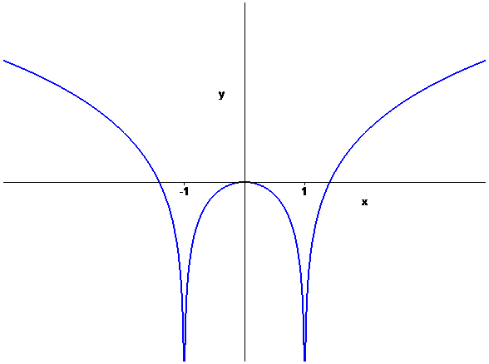
6. f⁻¹ ( x ) = x² + 2 , x ≥ 0
7.

8. $\frac{(\text{ x }+\text{ 2 })(\text{ x - 1 })^{2}}{3x−2} >\text{ 0 in }(\text{ -}∞\text{ , -2 })∪(\text{ 2/3 , 1 })∪(\text{ 1 , }+∞)$
9. 2 $\sqrt[\text{3 }]{\text{ 2}}$ , 1/3
10. ( 0 , ½ ) ( 1 , +∞)
11. ( 7/5 , 5 )

B

1. [ 0 , π/6 ) ( 5π/6 , 2 π )
2. C.E. ( -∞ , -1 ] SGN.: sempre negativa, nulla per x = -1
3. ( 0 , α ) α = arcsen 4/5 = arccos 3/5 = arctg 4/3 = 2 arctg 1/2
4. ( - ∞ , log₂3 )
5. $\sqrt{\sqrt{\text{ x - 1}}\text{ - 1}}$ , $\sqrt{\frac{1}{\text{1 - x}}\text{ - 1}} = \sqrt{\frac{x}{\text{1 - x}}}$
6. f⁻¹ ( x ) = x² - 2 , x ≥ 0
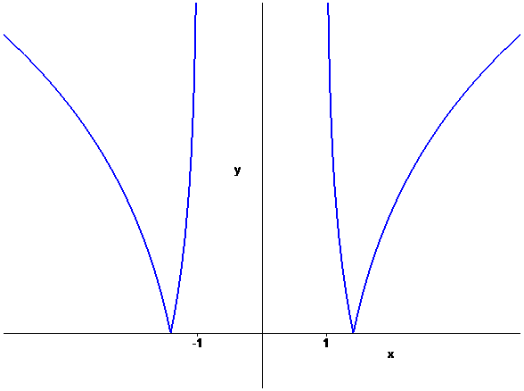
7.

8. $\frac{(\text{ x }−\text{ 2 })(\text{ x }+\text{ 1 })^{2}}{3x+2} >\text{ 0 in }(\text{ -}∞\text{ , -1 })∪(\text{ -1 , -2/3 })∪(\text{ 2 , }+∞)$
9. 3 $\sqrt[ ]{\text{ 3}}$ , 1/2
10. ( -∞ , - 1 ) ( -1/2 , 0 )
11. ( -5 , - 7/5 )

