[ A ]
1.
C.E. x $∈$ R , –π/2 < y ≤ π/2
Soluzioni costanti : y = π/2 ; poichè ( con la notazione standard ) B’ ( π/2 ) esiste, le altre soluzioni non la intersecano.
Nell’intervallo –π/2 < y < π/2 con il procedimento consueto per lo studio delle equazioni a variabili separate si trova:
$$\int{\frac{1+\text{ seny}}{\text{cosy}}}\text{ dy }= \int{\text{ dx}}$$
$$\int{\frac{1+\text{ seny}}{\text{cosy}}}\text{ dy }= \int{\text{ cosy }\frac{1+\text{ seny}}{{\text{cos}}^{2}y}\text{ dy }= }\int{\text{ cosy }\frac{1+\text{ seny}}{{\text{1 -sen}}^{2}y}\text{ dy }= }\int{ \frac{\text{cosy}}{\text{1 -seny}}\text{ dy }= }$$
= - log ( 1 – seny ) + c
Si ottiene dunque :
- log ( 1 – seny ) = x – c $⇒\text{ seny }={\text{ 1 - k e}}^{\text{-x}} (\text{ k }={\text{ e}}^{c}>\text{ 0 })$$⇒\text{ y }=\text{ arcsen }({\text{ 1 - k e}}^{\text{-x}})$
Tenendo conto che abbiamo separato le variabili nella condizione –π/2 < y < π/2 , deve essere – 1 < 1 - k e^{-x} < 1 $⇔$ k e^{-x} < 2 $⇔\text{ x }>\text{ log }(\text{ k / 2 })$.
Le soluzioni sono crescenti ( infatti nel C.E. y ‘ = $\frac{\text{cosy}}{\text{1 }+\text{ seny}}>\text{ 0 })$.
Per x →+∞ y ( x ) → π/2.
Per x →log ( k / 2 ) y ( x ) → -π/2.
Poichè per y → -π/2⁺ $\frac{\text{cosy}}{\text{1 }+\text{ seny}}→\text{ -}∞$, le curve partono con tangente verticale.
Poiché $\text{y}\text{= \{ \{}−senyy'\text{ \backslash ( }1\text{+}seny\text{ \backslash ) }−cos\text{ rSup \{ size 8\{2\} \} }yy'\text{\} over \{ \backslash ( 1+}seny\text{ \backslash ) rSup \{ size 8\{2\} \} \} \} =}−\text{ \{ \{}cosy\text{\} over \{ \backslash ( 1+}seny\text{ \backslash ) rSup \{ size 8\{2\} \} \} \} }\text{<}0\text{\} \{}$ , le curve sono concave.

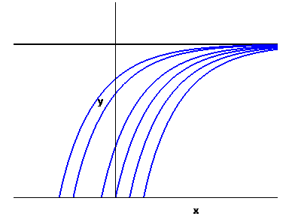

2.
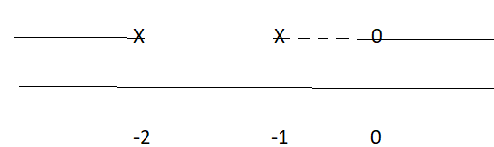C.E. $(\text{ -}∞\text{ , -2 })∪(\text{ -1 , }+∞)$
SGN f ( x ) ≥ 0 $⇔ \frac{\text{2 }(\text{ x }+\text{1 })}{\text{x }+\text{ 2}}≥\text{ 1 }⇔ \frac{x}{\text{x }+\text{ 2}} ≥\text{ 0}$
LIM x → -1 f ( x ) → 0 discontinuità eliminabile
x → -2 f ( x ) →+∞ asintoto vertricale
x →±∞ f ( x ) ≈ x² log2 →+∞ senza asintoto
DRV $\text{f ' }(\text{ x }) = (\text{ x }+\text{ 1 }) \left(\text{2 log }\frac{\text{2 }(\text{ x }+\text{1 })}{\text{x }+\text{ 2}} + \frac{1}{\text{x }+\text{ 2}}\right)$
Studio della funzione ϕ ( x ) = $\text{2 log }\frac{\text{2 }(\text{ x }+\text{1 })}{\text{x }+\text{ 2}} + \frac{1}{\text{x }+\text{ 2}}$
C.E. $(\text{ -}∞\text{ , -2 })∪(\text{ -1 , }+∞)$
LIM x → -1 f ( x ) → -∞
x → -2 f ( x ) → -∞
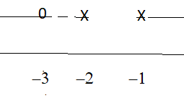x →±∞ f ( x ) → 2log2
DRV $ϕ\text{ ' }(\text{ x })= \frac{\text{2 }}{(\text{ x }+\text{ 1 })(\text{ x }+\text{ 2 })} − \frac{1}{(\text{ x }+\text{ 2 })^{2}} = \frac{\text{x }+\text{ 3}}{(\text{ x }+\text{ 1 })(\text{ x }+\text{ 2 })^{2}}$

GRAFICO
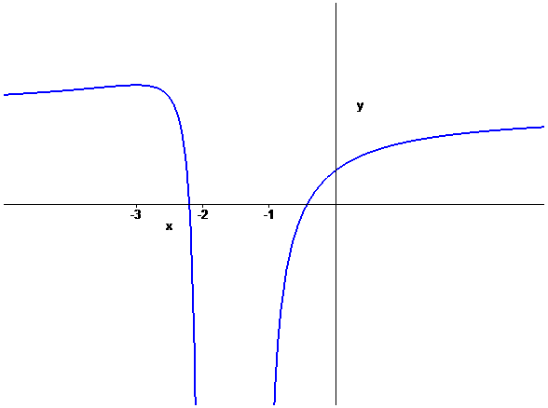
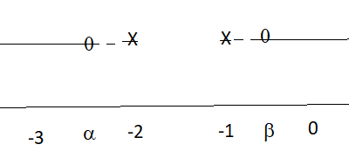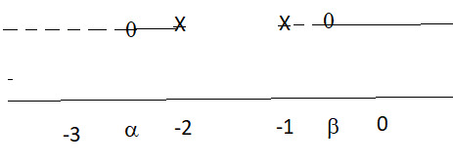
SGN ϕ ( x ) SGN f’ ( x )

GRAFICO di f ( x )
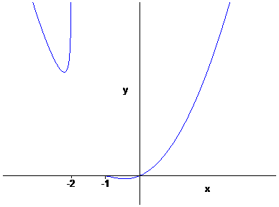
Per x → -1 f ‘ ( x ) → 0 ; x = -1 è una discontinuità eliminabile a tangente orizzontale

3.
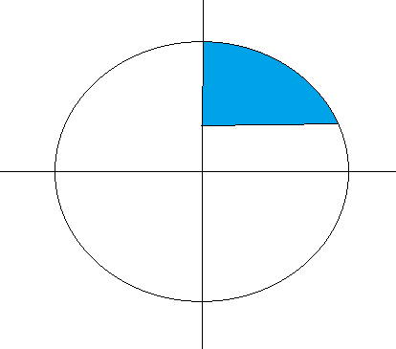
Area :
$$\int_{0}^{\sqrt{8}}{ (\sqrt{{\text{ 9 - x}}^{2}}}\text{ - 1 })\text{ dx }\overline{\overline{\text{x }=\text{ 3 sent}}}\text{ 9}\int_{0}^{\text{arcsen}(\sqrt{8}\text{ / 3 })}{{\text{ cos}}^{2}\text{t dt - }\sqrt{8} = }$$
= $\frac{9}{2} {\left[\text{ t }+\text{ sent cost }\right]}_{0}^{\text{arcsen}\sqrt{8}\text{/3}}\text{ - }\sqrt{8}$ = $\frac{9}{2} \left(\text{ arcsen }\frac{\sqrt{8}}{3} + \frac{\sqrt{8}}{9} \right)$- $\sqrt{8}$ =
= $\frac{9}{2}\text{ arcsen }\frac{\sqrt{8}}{3} − \frac{\sqrt{8}}{2}$

$\int_{1}^{3}{ \sqrt{{\text{ 9 - y}}^{2}}}\text{ dy }\overline{\overline{\text{y }=\text{ 3 sent}}}\text{ 9}\int_{\text{arcsen 1/3}}^{π\text{/2}}{{\text{ cos}}^{2}\text{t dt }= }\frac{9}{2} {\left[\text{ t }+\text{ sent cost }\right]}_{\text{arcsen1/3}}^{\text{π/2}}$ =
= $\frac{9}{2} \left( \frac{π}{2}\text{ - arcsen }\frac{1}{3}\text{ - }\frac{1}{3} \sqrt{\text{ 1 - }\frac{1}{9}} \right) = \frac{9}{2} \left(\frac{π}{2}\text{ - arcsen }\frac{1}{3}\text{ - }\frac{\sqrt{8}}{9}\right)$=
= $\frac{9}{2} \left(\frac{π}{2}\text{ - arcsen }\frac{1}{3} \right)\text{ - }\frac{\sqrt{8}}{2}$
I valori trovati sono diversi solo formalmente , dato che $\text{arcsen }\frac{\sqrt{8}}{3}$ $\frac{π}{2}\text{ - arcsen }\frac{1}{3}$, come si verifica facilmente calcolando il seno di entrambe le espressioni.

Volume
V = $\text{2 }π\int{\text{ x }(\sqrt{{\text{ 9 - x}}^{2}}}\text{ - 1 })\text{ dx }=\text{ 2 }π{\left[\text{ - }\frac{({\text{ 9 - x}}^{2})^{\text{3/2}}}{3}\text{ - }\frac{x^{2}}{2}\right]}_{ 0}^{\sqrt{8}}$= $\frac{\text{28}}{3}π$
V = $π\int{ ({\text{ 9 - y}}^{2}})\text{ dy }= \frac{\text{28}}{3}π$

[ B ]

1.
C.E. x $∈$ R , 0 ≤ y < π
Soluzioni costanti : y = 0 ; poichè ( con la notazione standard ) B’ ( 0 ) esiste, le altre soluzioni non la intersecano.
Nell’intervallo 0 < y < π con il procedimento consueto per lo studio delle equazioni a variabili separate si trova:
$$\int{\frac{1+\text{ cosy}}{\text{seny}}}\text{ dy }= \int{\text{ dx}}$$
$$\int{\frac{1+\text{ cosy}}{\text{seny}}}\text{ dy }= \int{\text{ seny }\frac{1+\text{ cosy}}{{\text{sen}}^{2}y}\text{ dy }= }\int{\text{ seny }\frac{1+\text{ cosy}}{{\text{1 - cos}}^{2}y}\text{ dy }= }\int{ \frac{\text{seny}}{\text{1 - cosy}}\text{ dy }= }$$
= - log ( 1 – cosy ) + c
Si ottiene dunque :
log ( 1 – cosy ) = x – c $⇒\text{ cosy }={\text{ 1 - k e}}^{x} (\text{ k }={\text{ e}}^{\text{-c}}>\text{ 0 })$$⇒\text{ y }=\text{ arccos }({\text{ 1 - k e}}^{x})$
Tenendo conto che abbiamo separato le variabili nella condizione 0 < y < π , deve essere – 1 < 1 - k e^{x} < 1 $⇔$ k e^{x} < 2 $⇔\text{ x }<\text{ log }(\text{ 2 / k })$.
Le soluzioni sono crescenti ( infatti nel C.E. y ‘ = $\frac{\text{cosy}}{\text{1 }+\text{ seny}}>\text{ 0 })$.
Per x →-∞ y ( x ) → 0.
Per x →log ( 2 / k ) y ( x ) → π.
Poichè per y → π⁻ $\frac{\text{seny}}{\text{1 }+\text{ cosy}}→+∞$, le curve arrivano con tangente verticale.
Poiché $\text{y}\text{= \{ \{}cosyy'\text{ \backslash ( }1\text{+}cosy\text{ \backslash ) +}sen\text{ rSup \{ size 8\{2\} \} }yy'\text{\} over \{ \backslash ( 1+}cosy\text{ \backslash ) rSup \{ size 8\{2\} \} \} \} =}\text{ \{ \{}seny\text{\} over \{ \backslash ( }1\text{+}cosy\text{ \backslash ) rSup \{ size 8\{2\} \} \} \} }\text{>}0\text{\} \{}$ , le curve sono convesse.

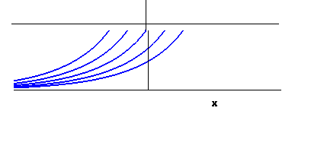
2.
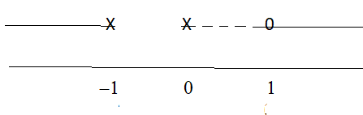C.E. $(\text{ -}∞\text{ , -1 })∪(\text{ 0 , }+∞)$
SGN f ( x ) ≥ 0 $⇔ \frac{\text{2 x}}{\text{x }+\text{ 1}}≥\text{ 1 }⇔ \frac{\text{x - 1}}{\text{x }+\text{ 1}} ≥\text{ 0}$
LIM x → 0 f ( x ) → 0 discontinuità eliminabile
x → -1 f ( x ) →+∞ asintoto vertricale
x →±∞ f ( x ) ≈ x² log2 →+∞ senza asintoto
DRV $\text{f ' }(\text{ x }) =\text{ x }\left(\text{2 log }\frac{\text{2 x}}{\text{x }+\text{ 1}} + \frac{1}{\text{x }+\text{ 1}}\right)$
Studio della funzione ϕ ( x ) = $\text{2 log }\frac{\text{2 x}}{\text{x }+\text{ 1}} + \frac{1}{\text{x }+\text{ 1}}$
C.E. $(\text{ -}∞\text{ , -1 })∪(\text{ 0 , }+∞)$
LIM x → -1 f ( x ) → -∞
x → 0 f ( x ) → -∞
x →±∞ f ( x ) → 2log2
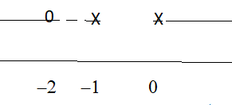DRV $ϕ\text{ ' }(\text{ x }) = \frac{\text{2 }}{\text{x }(\text{ x }+\text{ 1 })} − \frac{1}{(\text{ x }+\text{ 1 })^{2}} = \frac{\text{x }+\text{ 2}}{\text{x }(\text{ x }+\text{ 1 })^{2}}$

GRAFICO
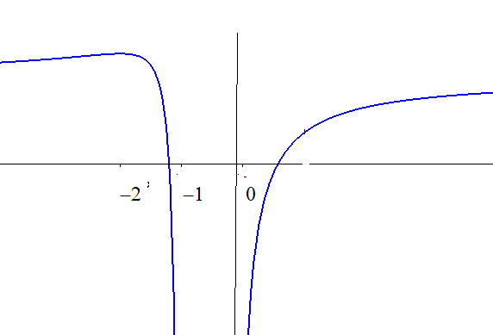

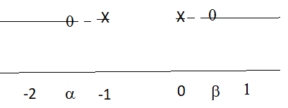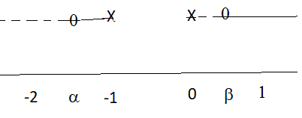
SGN ϕ ( x ) SGN f’ ( x )

GRAFICO di f ( x )
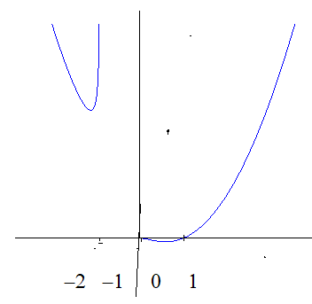
Per x → 0 f ‘ ( x ) → 0 ; x = 0 è una discontinuità eliminabile a tangente orizzontale

3.

Area :
$$\int_{0}^{\sqrt{\text{12}}}{ (\sqrt{{\text{ 16 - x}}^{2}}}\text{ - 2 })\text{ dx }\overline{\overline{\text{x }=\text{ 4 sent}}}\text{ 16}\int_{0}^{\text{arcsen}(\sqrt{\text{12}}\text{ / 4 })}{{\text{ cos}}^{2}\text{t dt - 2 }\sqrt{\text{12}} = }$$
= $\text{8 }{\left[\text{ t }+\text{ sent cost }\right]}_{0}^{\text{arcsen}\sqrt{3}\text{/2}}\text{ - 4 }\sqrt{3}$ = $8 \left(\frac{π}{3} + \frac{\sqrt{3}}{4} \right)$- $4\sqrt{3}$ =
= $\frac{8}{3} π −\text{ 2 }\sqrt{3}$

$\int_{2}^{4}{ \sqrt{{\text{ 16 - y}}^{2}}}\text{ dy }\overline{\overline{\text{y }=\text{ 4 sent}}}\text{ 16}\int_{\text{arcsen 1/2}}^{π\text{/2}}{{\text{ cos}}^{2}\text{t dt }= }\text{8 }{\left[\text{ t }+\text{ sent cost }\right]}_{π\text{/6}}^{\text{π/2}}$ =
= $8 \left( \frac{π}{2}\text{ - }\frac{π}{6}\text{ - }\frac{1}{2} \sqrt{\text{ 1 - }\frac{1}{4}} \right) = 8 \left(\frac{π}{3}\text{ - }\frac{\sqrt{3}}{4}\right)$= $\frac{8}{3} π −\text{ 2 }\sqrt{3}$

Volume
V = $\text{2 }π\int{\text{ x }(\sqrt{{\text{ 16 - x}}^{2}}}\text{ - 2 })\text{ dx }=\text{ 2 }π{\left[\text{ - }\frac{({\text{ 16 - x}}^{2})^{\text{3/2}}}{3}{\text{ - x}}^{2}\right]}_{ 0}^{\sqrt{\text{12}}}$= $\frac{\text{40}}{3}π$
V = $π\int{ ({\text{ 16 - y}}^{2}})\text{ dy }= \frac{\text{40}}{3}π$

[ C ]

1. C.E. x $∈$ R , –π/2 ≤ y < π/2
Soluzioni costanti : y = -π/2 ; poichè ( con la notazione standard ) B’ ( -π/2 ) esiste, le altre soluzioni non la intersecano.
Nell’intervallo –π/2 < y < π/2 con il procedimento consueto per lo studio delle equazioni a variabili separate si trova:
$$\int{\frac{1−\text{ seny}}{\text{cosy}}}\text{ dy }= \int{\text{ dx}}$$
$$\int{\frac{1−\text{ seny}}{\text{cosy}}}\text{ dy }= \int{\text{ cosy }\frac{1−\text{ seny}}{{\text{cos}}^{2}y}\text{ dy }= }\int{\text{ cosy }\frac{1−\text{ seny}}{{\text{1 -sen}}^{2}y}\text{ dy }= }\int{ \frac{\text{cosy}}{\text{1 }+\text{seny}}\text{ dy }= }$$
= log ( 1 + seny ) + c
Si ottiene dunque :
log ( 1 + seny ) = x – c $⇒\text{ seny }={\text{ k e}}^{x}\text{ - 1 }(\text{ k }={\text{ e}}^{\text{-c}}>\text{ 0 })$$⇒\text{ y }=\text{ arcsen }({\text{ k e}}^{x}\text{ - 1 })$
Tenendo conto che abbiamo separato le variabili nella condizione –π/2 < y < π/2 , deve essere – 1 < k e^{x} – 1 < 1 $⇔$ k e^{x} < 2 $⇔\text{ x }<\text{ log }(\text{ 2 / k })$.
Le soluzioni sono crescenti ( infatti nel C.E. y ‘ = $\frac{\text{cosy}}{\text{1 }−\text{ seny}}>\text{ 0 })$.
Per x →-∞ y ( x ) →- π/2.
Per x →log ( 2 / k ) y ( x ) → π/2.
Poichè per y → π/2⁻ $\frac{\text{cosy}}{\text{1 }−\text{ seny}}→+∞$, le curve arrivano con tangente verticale.
Poiché $\text{y}\text{= \{ \{}−senyy'\text{ \backslash ( }1\text{ - }seny\text{ \backslash ) +}cos\text{ rSup \{ size 8\{2\} \} }yy'\text{\} over \{ \backslash ( 1 - }seny\text{ \backslash ) rSup \{ size 8\{2\} \} \} \} = \{ \{}cosy\text{\} over \{ \backslash ( 1+}seny\text{ \backslash ) rSup \{ size 8\{2\} \} \} \} }\text{>}0\text{\} \{}$ , le curve sono convesse.

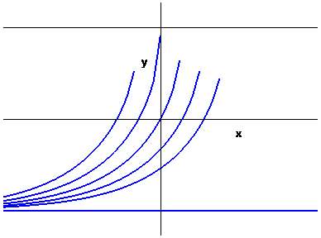
2.
C.E. $(\text{ -}∞\text{ , -1 })∪(\text{ 0 , }+∞)$
SGN f ( x ) ≥ 0 $⇔ \frac{\text{2 x}}{\text{x }+\text{ 1}}≥\text{ 1 }⇔ \frac{\text{x - 1}}{\text{x }+\text{ 1}} ≥\text{ 0}$
LIM x → 0 f ( x ) → 0 discontinuità eliminabile
x → -1 f ( x ) →+∞ asintoto vertricale
x →±∞ f ( x ) ≈ x² log2 →+∞ senza asintoto
DRV $\text{f ' }(\text{ x }) =\text{ x }\left(\text{2 log }\frac{\text{2 x}}{\text{x }+\text{ 1}} + \frac{1}{\text{x }+\text{ 1}}\right)$
Studio della funzione ϕ ( x ) = $\text{2 log }\frac{\text{2 x}}{\text{x }+\text{ 1}} + \frac{1}{\text{x }+\text{ 1}}$
C.E. $(\text{ -}∞\text{ , -1 })∪(\text{ 0 , }+∞)$
LIM x → -1 f ( x ) → -∞
x → 0 f ( x ) → -∞
x →±∞ f ( x ) → 2log2
DRV $ϕ\text{ ' }(\text{ x }) = \frac{\text{2 }}{\text{x }(\text{ x }+\text{ 1 })} − \frac{1}{(\text{ x }+\text{ 1 })^{2}} = \frac{\text{x }+\text{ 2}}{\text{x }(\text{ x }+\text{ 1 })^{2}}$

GRAFICO
SGN ϕ ( x ) SGN f’ ( x )

GRAFICO di f ( x )
Per x → 0 f ‘ ( x ) → 0 ; x = 0 è una discontinuità eliminabile a tangente orizzontale

3.
Area :
$$\int_{0}^{\sqrt{8}}{ (\sqrt{{\text{ 9 - x}}^{2}}}\text{ - 1 })\text{ dx }\overline{\overline{\text{x }=\text{ 3 sent}}}\text{ 9}\int_{0}^{\text{arcsen}(\sqrt{8}\text{ / 3 })}{{\text{ cos}}^{2}\text{t dt - }\sqrt{8} = }$$
= $\frac{9}{2} {\left[\text{ t }+\text{ sent cost }\right]}_{0}^{\text{arcsen}\sqrt{8}\text{/3}}\text{ - }\sqrt{8}$ = $\frac{9}{2} \left(\text{ arcsen }\frac{\sqrt{8}}{3} + \frac{\sqrt{8}}{9} \right)$- $\sqrt{8}$ =
= $\frac{9}{2}\text{ arcsen }\frac{\sqrt{8}}{3} − \frac{\sqrt{8}}{2}$

$\int_{1}^{3}{ \sqrt{{\text{ 9 - y}}^{2}}}\text{ dy }\overline{\overline{\text{y }=\text{ 3 sent}}}\text{ 9}\int_{\text{arcsen 1/3}}^{π\text{/2}}{{\text{ cos}}^{2}\text{t dt }= }\frac{9}{2} {\left[\text{ t }+\text{ sent cost }\right]}_{\text{arcsen1/3}}^{\text{π/2}}$ =
= $\frac{9}{2} \left( \frac{π}{2}\text{ - arcsen }\frac{1}{3}\text{ - }\frac{1}{3} \sqrt{\text{ 1 - }\frac{1}{9}} \right) = \frac{9}{2} \left(\frac{π}{2}\text{ - arcsen }\frac{1}{3}\text{ - }\frac{\sqrt{8}}{9}\right)$=
= $\frac{9}{2} \left(\frac{π}{2}\text{ - arcsen }\frac{1}{3} \right)\text{ - }\frac{\sqrt{8}}{2}$
I valori trovati sono diversi solo formalmente , dato che $\text{arcsen }\frac{\sqrt{8}}{3}$ $\frac{π}{2}\text{ - arcsen }\frac{1}{3}$, come si verifica facilmente calcolando il seno di entrambe le espressioni.

Volume
V = $\text{2 }π\int{\text{ x }(\sqrt{{\text{ 9 - x}}^{2}}}\text{ - 1 })\text{ dx }=\text{ 2 }π{\left[\text{ - }\frac{({\text{ 9 - x}}^{2})^{\text{3/2}}}{3}\text{ - }\frac{x^{2}}{2}\right]}_{ 0}^{\sqrt{8}}$= $\frac{\text{28}}{3}π$
V = $π\int{ ({\text{ 9 - y}}^{2}})\text{ dy }= \frac{\text{28}}{3}π$

[ D ]

1.
C.E. x $∈$ R , 0 < y ≤ π
Soluzioni costanti : y = π ; poichè ( con la notazione standard ) B’ ( π ) esiste, le altre soluzioni non la intersecano.
Nell’intervallo 0 < y < π con il procedimento consueto per lo studio delle equazioni a variabili separate si trova:
$$\int{\frac{1−\text{ cosy}}{\text{seny}}}\text{ dy }= \int{\text{ dx}}$$
$$\int{\frac{1−\text{ cosy}}{\text{seny}}}\text{ dy }= \int{\text{ seny }\frac{1−\text{ cosy}}{{\text{sen}}^{2}y}\text{ dy }= }\int{\text{ seny }\frac{1−\text{ cosy}}{{\text{1 - cos}}^{2}y}\text{ dy }= }\int{ \frac{\text{seny}}{\text{1 }+\text{ cosy}}\text{ dy }= }$$
= - log ( 1 + cosy ) + c
Si ottiene dunque :
- log ( 1 + cosy ) = x – c $⇒\text{ cosy }={\text{ k e}}^{\text{-x}}\text{ - 1 }(\text{ k }={\text{ e}}^{c}>\text{ 0 })$$⇒\text{ y }=\text{ arccos }({\text{ k e}}^{\text{-x}}\text{ - 1 })$
Tenendo conto che abbiamo separato le variabili nella condizione 0 < y < π , deve essere – 1 < k e^{-x} - 1 < 1 $⇔$ k e^{-x} < 2 $⇔\text{ x }>\text{ log }(\text{ k / 2 })$.
Le soluzioni sono crescenti ( infatti nel C.E. y ‘ = $\frac{\text{seny}}{\text{1 - cosy}}>\text{ 0 })$.
Per x →+∞ y ( x ) → π.
Per x →log ( k / 2 ) y ( x ) → 0.
Poichè per y → 0⁺ $\frac{\text{seny}}{\text{1 }−\text{ cosy}}→+∞$, le curve partono con tangente verticale.
Poiché $\text{y}\text{= \{ \{}cosyy'\text{ \backslash ( }1\text{ - }cosy\text{ \backslash ) - }sen\text{ rSup \{ size 8\{2\} \} }yy'\text{\} over \{ \backslash ( 1 - }cosy\text{ \backslash ) rSup \{ size 8\{2\} \} \} \} =}\text{ \{ \{}−seny\text{\} over \{ \backslash ( }1\text{+}cosy\text{ \backslash ) rSup \{ size 8\{2\} \} \} \} }\text{<}0\text{\} \{}$ , le curve sono concave.

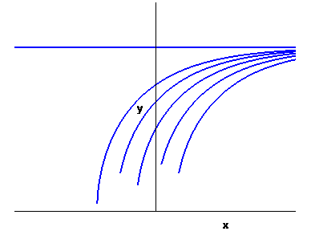

2.
C.E. $(\text{ -}∞\text{ , -2 })∪(\text{ -1 , }+∞)$
SGN f ( x ) ≥ 0 $⇔ \frac{\text{2 }(\text{ x }+\text{1 })}{\text{x }+\text{ 2}}≥\text{ 1 }⇔ \frac{x}{\text{x }+\text{ 2}} ≥\text{ 0}$
LIM x → -1 f ( x ) → 0 discontinuità eliminabile
x → -2 f ( x ) →+∞ asintoto vertricale
x →±∞ f ( x ) ≈ x² log2 →+∞ senza asintoto
DRV $\text{f ' }(\text{ x }) = (\text{ x }+\text{ 1 }) \left(\text{2 log }\frac{\text{2 }(\text{ x }+\text{1 })}{\text{x }+\text{ 2}} + \frac{1}{\text{x }+\text{ 2}}\right)$
Studio della funzione ϕ ( x ) = $\text{2 log }\frac{\text{2 }(\text{ x }+\text{1 })}{\text{x }+\text{ 2}} + \frac{1}{\text{x }+\text{ 2}}$
C.E. $(\text{ -}∞\text{ , -2 })∪(\text{ -1 , }+∞)$
LIM x → -1 f ( x ) → -∞
x → -2 f ( x ) → -∞
x →±∞ f ( x ) → 2log2
DRV $ϕ\text{ ' }(\text{ x }) = \frac{\text{2 }}{(\text{ x }+\text{ 1 })(\text{ x }+\text{ 2 })} − \frac{1}{(\text{ x }+\text{ 2 })^{2}} = \frac{\text{x }+\text{ 3}}{(\text{ x }+\text{ 1 })(\text{ x }+\text{ 2 })^{2}}$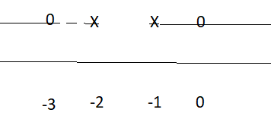

GRAFICO
SGN ϕ ( x ) SGN f’ ( x )

GRAFICO di f ( x )
Per x → -1 f ‘ ( x ) → 0 ; x = -1 è una discontinuità eliminabile a tangente orizzontale

3.
Area :
$$\int_{0}^{\sqrt{\text{12}}}{ (\sqrt{{\text{ 16 - x}}^{2}}}\text{ - 2 })\text{ dx }\overline{\overline{\text{x }=\text{ 4 sent}}}\text{ 16}\int_{0}^{\text{arcsen}(\sqrt{\text{12}}\text{ / 4 })}{{\text{ cos}}^{2}\text{t dt - 2 }\sqrt{\text{12}} = }$$
= $\text{8 }{\left[\text{ t }+\text{ sent cost }\right]}_{0}^{\text{arcsen}\sqrt{3}\text{/2}}\text{ - 4 }\sqrt{3}$ = $8 \left(\frac{π}{3} + \frac{\sqrt{3}}{4} \right)$- $4\sqrt{3}$ =
= $\frac{8}{3} π −\text{ 2 }\sqrt{3}$

$\int_{2}^{4}{ \sqrt{{\text{ 16 - y}}^{2}}}\text{ dy }\overline{\overline{\text{y }=\text{ 4 sent}}}\text{ 16}\int_{\text{arcsen 1/2}}^{π\text{/2}}{{\text{ cos}}^{2}\text{t dt }= }\text{8 }{\left[\text{ t }+\text{ sent cost }\right]}_{π\text{/6}}^{\text{π/2}}$ =
= $8 \left( \frac{π}{2}\text{ - }\frac{π}{6}\text{ - }\frac{1}{2} \sqrt{\text{ 1 - }\frac{1}{4}} \right) = 8 \left(\frac{π}{3}\text{ - }\frac{\sqrt{3}}{4}\right)$= $\frac{8}{3} π −\text{ 2 }\sqrt{3}$

Volume
V = $\text{2 }π\int{\text{ x }(\sqrt{{\text{ 16 - x}}^{2}}}\text{ - 2 })\text{ dx }=\text{ 2 }π{\left[\text{ - }\frac{({\text{ 16 - x}}^{2})^{\text{3/2}}}{3}{\text{ - x}}^{2}\right]}_{ 0}^{\sqrt{\text{12}}}$= $\frac{\text{40}}{3}π$
V = $π\int{ ({\text{ 16 - y}}^{2}})\text{ dy }= \frac{\text{40}}{3}π$

