Soluzioni test [ A ]
1.
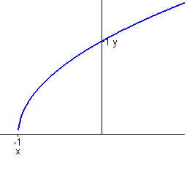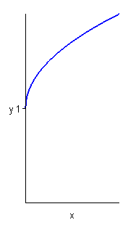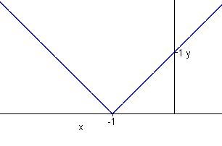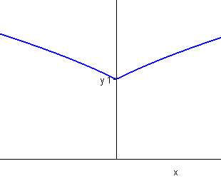
2. 3. 5.
α $∈$ ( 0 , 3/2 ) k $∈$ $\left\{\text{ 0 }\right\}∪({\text{ 4 e}}^{\text{-2}}\text{ , }+∞)$ [ -3/2 , 0 ]

4.
f continua in [ a , b ] , derivabile in ( a , b ) , f ( a ) = f ( b ) $⇒ ∃ξ∈(\text{ a , b }){\text{ : f}}^{'}(ξ)=\text{ 0}$
6.
( i ) $∀\text{ x }∈\text{ A , f }(\text{ x })≤\text{ L}$ (ii) $∀ε>\text{ 0 , }∃\overline{x}∈\text{ A : f }(\overline{x})>\text{ L - }ε$
Soluzioni test [ B ]
1.
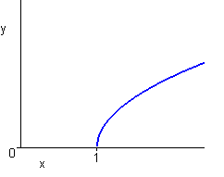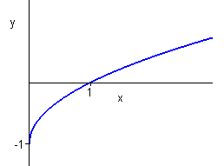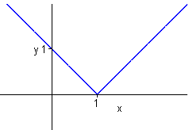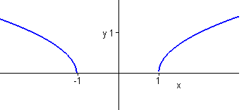
2. 3. 5.
nessun valore k $∈$ $\left\{\text{ 0 }\right\}∪({\text{ 4 e}}^{\text{-2}}\text{ , }+∞)$ [ -2/3 , 0 ]
4.
${\text{lim}}_{x→x_{0}}\text{ f }(\text{ x })=\text{ L }>0$ $⇒ ∃U({\text{ x}}_{0})\text{ : }∀\text{ x }∈\text{ A }∩U({\text{ x}}_{0})\text{ - }\left\{{\text{ x}}_{0}\right\}\text{ , f }(x)>\text{ 0}$
6.
( i ) $∀\text{ x }∈\text{ A , f }(\text{ x })≥\text{ l}$ (ii) $∀ε>\text{ 0 , }∃\overline{x}∈\text{ A : f }(\overline{x})<\text{ l }+ε$
Soluzioni test [ C ]
1.
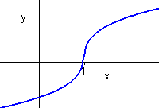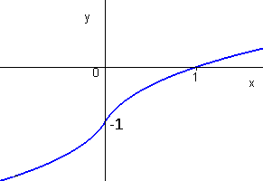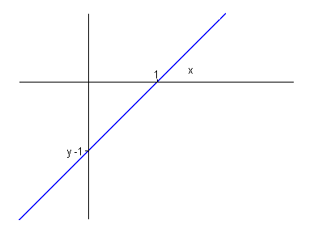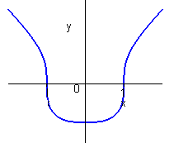
2. 3. 5.
α $∈$ ( 0 , 1 ) k $∈$ $({\text{ 0 , e}}^{2}\text{ / 4 })$ [ -13/4 , 5/4 ]
4.
( i ) P ( 1 ) vera ( ii ) $∀n∈\text{ N}$, P ( n ) vera $⇒$ P ( n + 1 ) vera
Tesi: $∀n∈\text{ N}$, P ( n ) vera
6.
( i ) $∀\text{ x }∈\text{ A , f }(\text{ x })≤\text{ M}$ (ii) $∃\overline{x}∈\text{ A : f }(\overline{x})=\text{ M}$
Soluzioni test [ D ]
1.
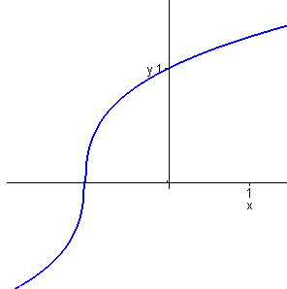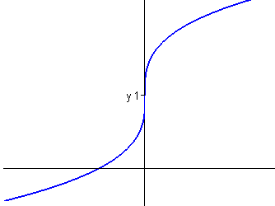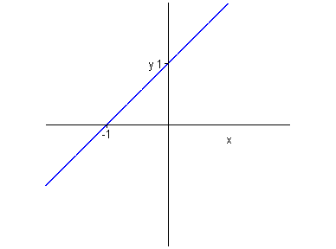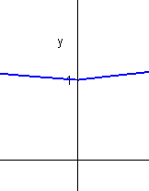
2. 3. 5.
α $∈$ ( 0 , +∞ ) k $∈$ $\left\{\text{ 0 }\right\}∪({\text{ 256 e}}^{\text{-4}}\text{ , }+∞)$ [ -5/4 , 13/4 ]
4.
x₀ punto di massimo o minimo locale o assoluto interno , f derivabile in x₀
Tesi: f’ ( x₀ ) = 0
6.
( i ) $∀\text{ x }∈\text{ A , f }(\text{ x })≥\text{ m}$ (ii) $∃\overline{x}∈\text{ A : f }(\overline{x})=\text{ m}$

